View 1: Dashboard default view
THIS IS THE DEFAULT VIEW WHEN THE APPLICATION STARTS. This shows the present running tasks, option to search previously saved tasks, Application name in the top. The name “Task Dashboard”. Recently activated tasks,

View 2: Tasks
This will show all the task user has added in a table like structure. It has column task name, total active time, current session active period, last start time and end time.There is a search option to search task. Also have option to view all the task, current active task, and the deactivated tasks. Also in this view user has the option to filter the task by date, time period, tag names and other suitable parameters. Filtering option appears in left side as a side bar. It must show the current active filters and clear option to recet the filters.
When user click a task, a side bar from right appears with all the details related to particular task should appear. That include task name, total active time, added date, start button, tags related to the task, edit button which allow user to edit task name, tags, [any other thing need to edit add to here].

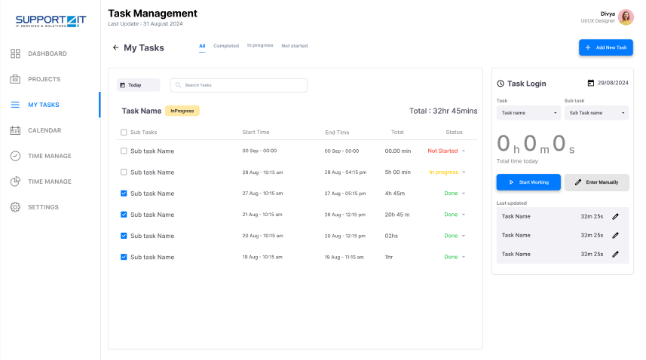

View 3: Analytics
User can perform various analytics in this view

Navigation:
Side bar contains all the navigation links. All views names. User have the option to hide the side bar if he want and get back it in tha same time. - ------------------------------------------------------

